JOB DESCRIPTION 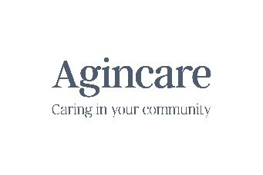
JOB TITLE: | Health Care Assistant
DEPARTMENT: | Live in Care Services / Homecare / Care Homes
REPORTING TO: | Registered Manager
PURPOSE
The main purpose of the role of Health Care Assistant is to support all those who use our services to live well, to protect them from harm including any form of abuse, prevent deterioration of (and promote) physical and mental health plus positive well-being to encourage independence.
MAIN DUTIES AND RESPONSIBLITIES
- To assist those who use our service with all aspects of personal care including, washing, personal hygiene, dressing and assisting with meals
- To support and encourage those who use our service to participate in daily activities of their choice such as day trips, recreational or leisure activities, crafts, reading, writing.
- To follow all care plan instructions and guidance without deviation unless directed by the Registered Manager.
- To ensure all documentation relevant to those who use our service is accurate and up-to-date at all times.
- To support and enable access to, and work collaboratively with, other health and social care professionals
- To remain in-date for all mandatory training and demonstrate competence in the role when required to do so. To promote and adhere to Agincare’s values at all times.
- Any other appropriate tasking allocated by the Registered Manager

PERSON SPECIFICATION (E=Essential, D=Desirable)
Criteria |  | E/D | Source of Criteria Evidence
Caring and compassionate |  | E | Interview
Excellent organisational skills |  | E | Interview/Application
Able to work on own initiative |  | E | Interview/Application
Self-motivated and flexible |  | E | Interview/Application
Ability to provide emotional and social support whilst promoting dignity and respect |  | E | Interview
Excellent communication skills. Good standard of written and verbal English |  | E | Interview/Application
Excellent attendance and punctuality record. |  | E | References
Passionate about providing a high standard of care and making a difference |  | E | Interview/Application/References
QCF units in health and social care or equivalent (an opportunity to undertake this will be available) |  | D | Application
JOB DESCRIPTION AGREEMENT
Job Holder signature:

Line Manager signature: Date:
The purpose of this Job Description is to indicate the general level of responsibility of the post. The detailed duties may vary from time to time without changing the general character or level of responsibility. By signing above you are agreeing to undertake your employment in adherence with this job description.
Amendments to the role are made through the supervision process where required and to develop practice, please forward a signed copy of the suggested amendments to the HR Department.

